+5V Raw Back Powering
- Supply external +5V @ 30mA min current limited supply to +5V and GND inputs on RPI header
- Measure voltage across C6, C12 or C13 and ensure voltage measurement is less than 0.5V
Results: Voltage read 0V across C13 when a +5V supply was connected to RPI header. Body diode of Q1 is correctly preventing a back-powering event
PLM EXT CLK INPUT
- Measure CLK signal supplied at CLK_OUT pin of PLM IC using an oscilloscope.
- Verify measured CLK_OUT frequency equals fosc/2 = 4MHz.
Results:
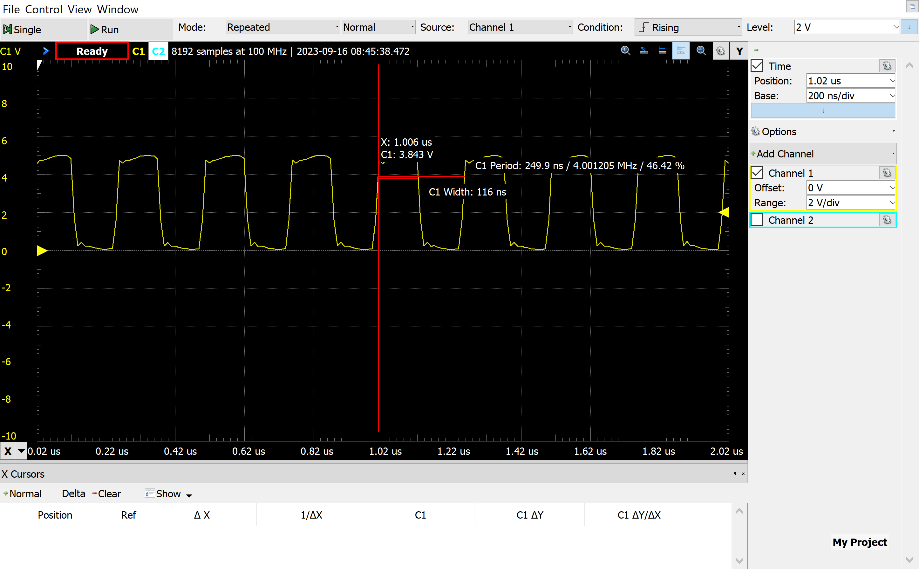
PLM TX OUTPUT
- Supply a square waveform generator to PLM TX pin
- Measure signal at ACIN output
Results
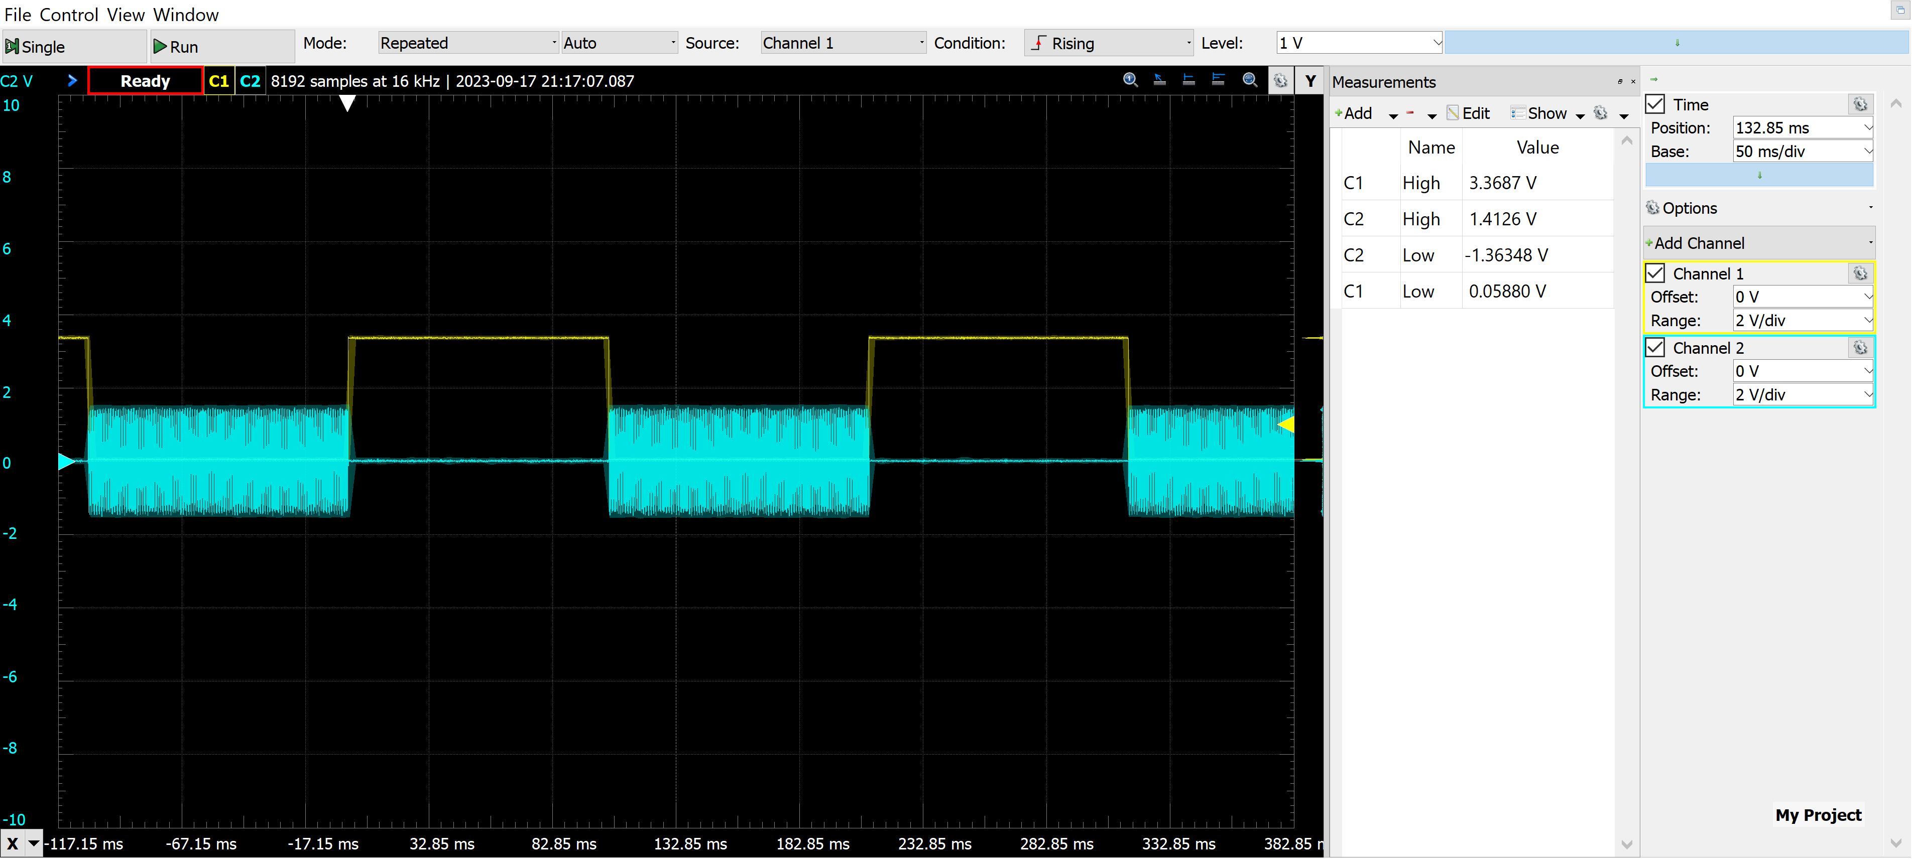
JARViE was sent on RPI ttyS0 serial bus: 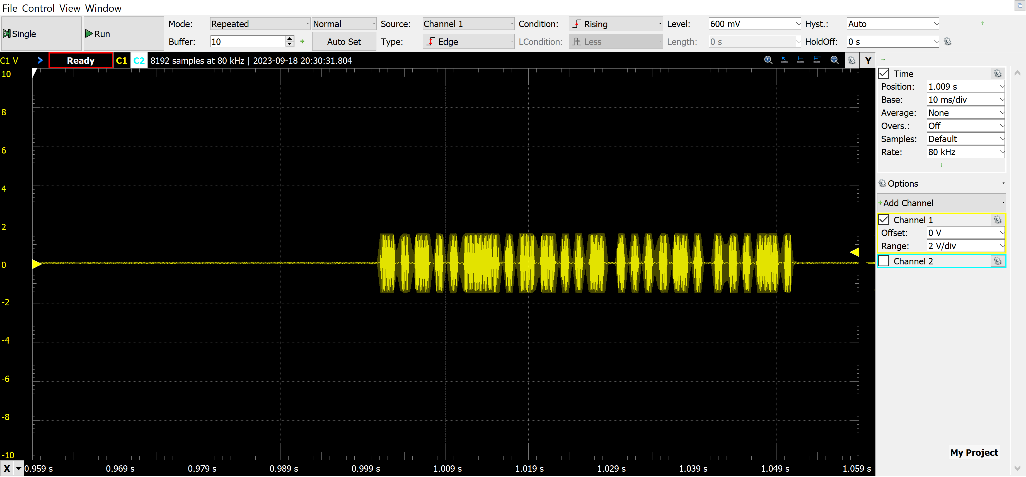
Communications Carrier frequency:
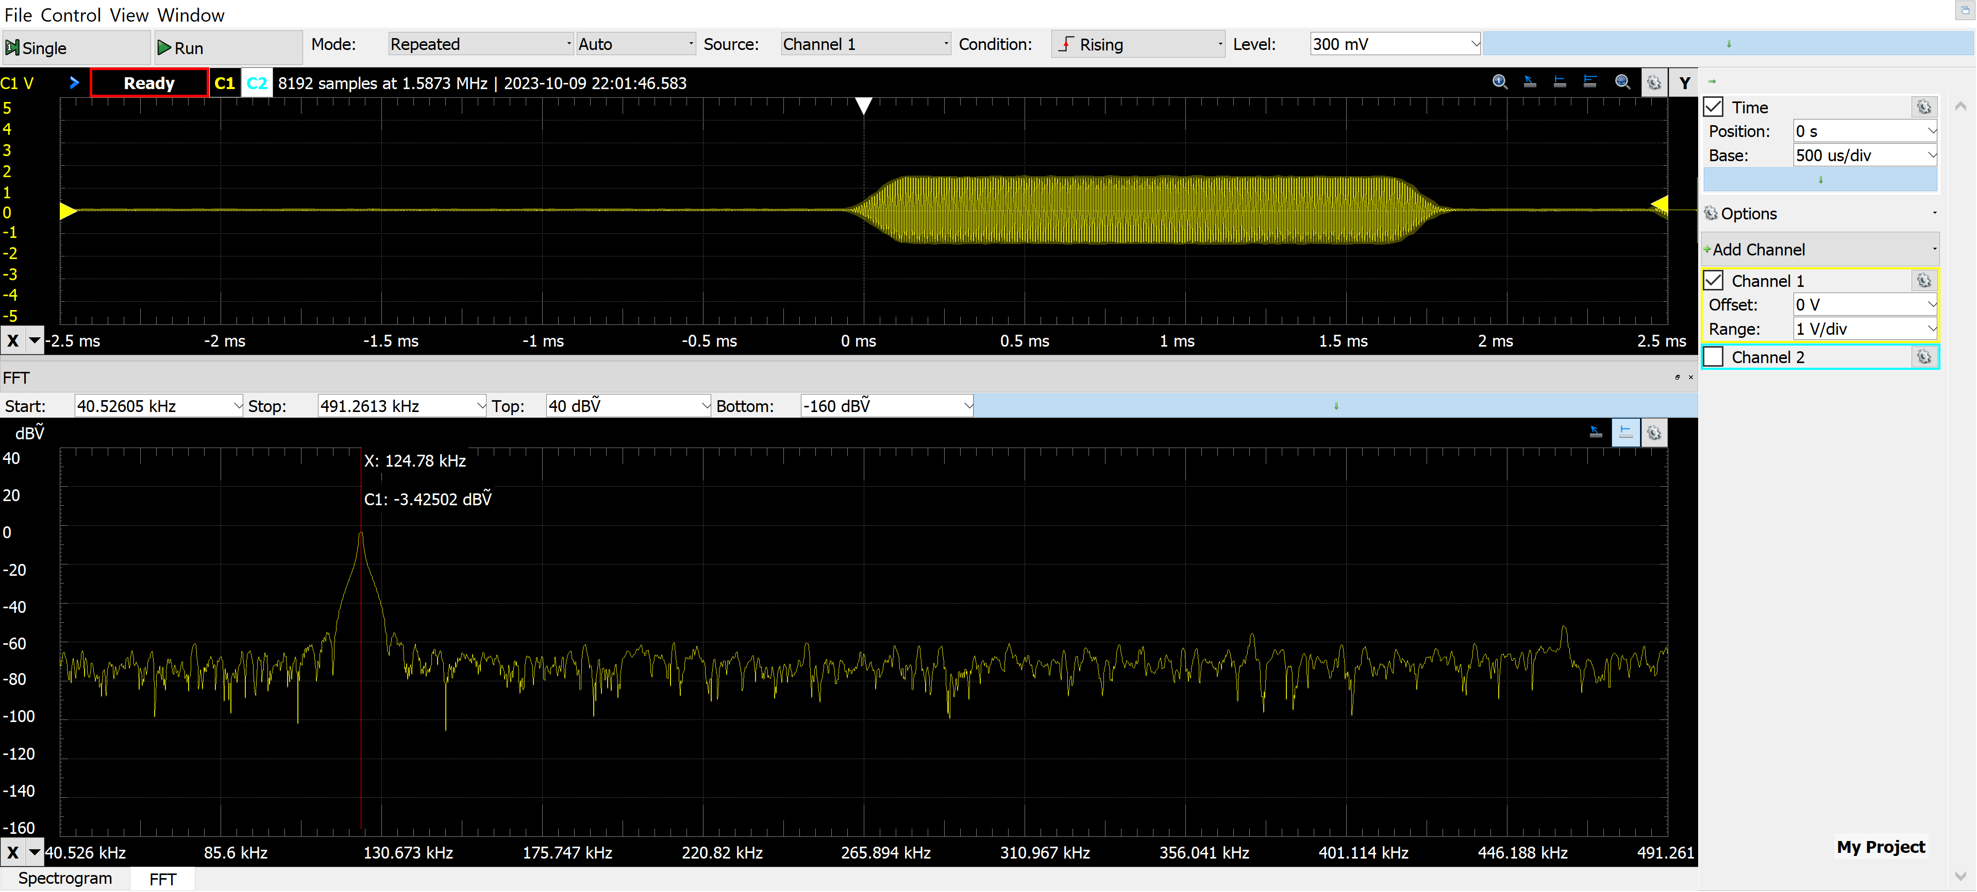
RPI BOOT w/ AC power adapter
- Power down raspberry PI
- Plug RPI Shield into raspberry PI
- Power on raspberry PI using a USB-C power adapter (5V @ ?A)
- Verify PI boots normally
- Measure +3V and +5V power rails on the shield
Results
PI boots up properly
+3V and +5V power rails look good
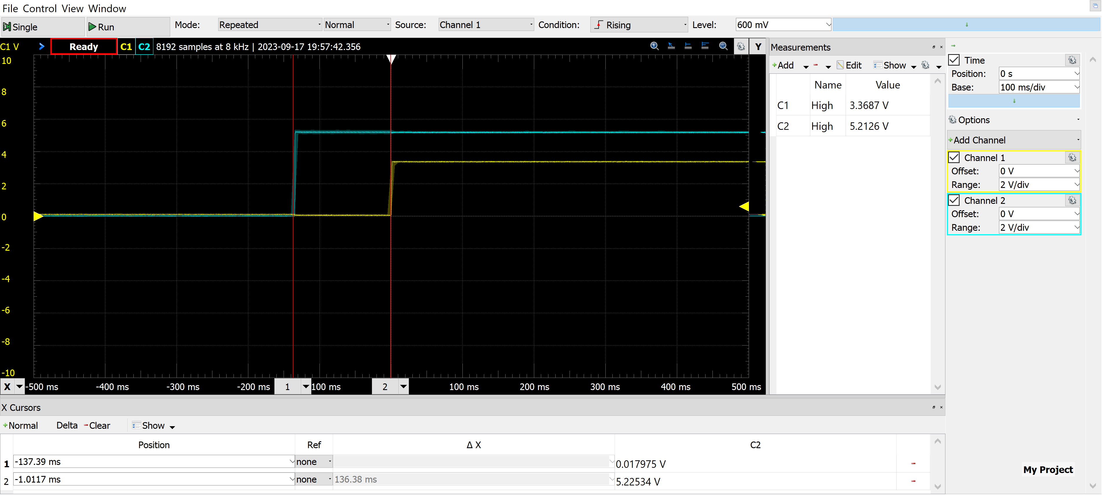

RPI BOOT w/ Shield 115VAC power
- Power down raspberry PI
- Plug RPI Shield into raspberry PI
- Connect AC power to RPI Shield via ACIN connector
- Plug AC power plug into 115VAC wall outlet
- Verify PI boots normally
- Measure ACIN, +3V and +5V power rails on the shield w/ DMM
Results
RPI booted up properly
ACIN = 124.0 VAC
+5V = 4.94 VDC
+3V = 3.29 VDC

3V to 5V Level Translation
- Generate square wave on PLM DIN RPI TX pin
- Connect scope to PLM DIN RPI TX pin and set scope to trigger on rising edge of this signal
- Connect scope to PLM DIN pin
Results
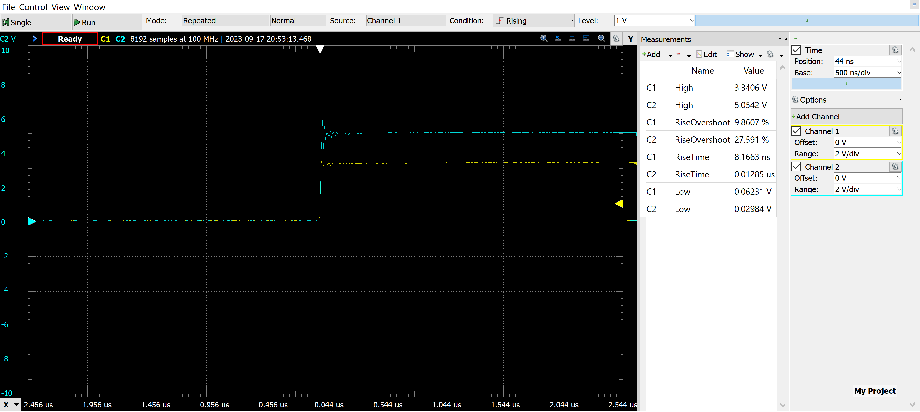

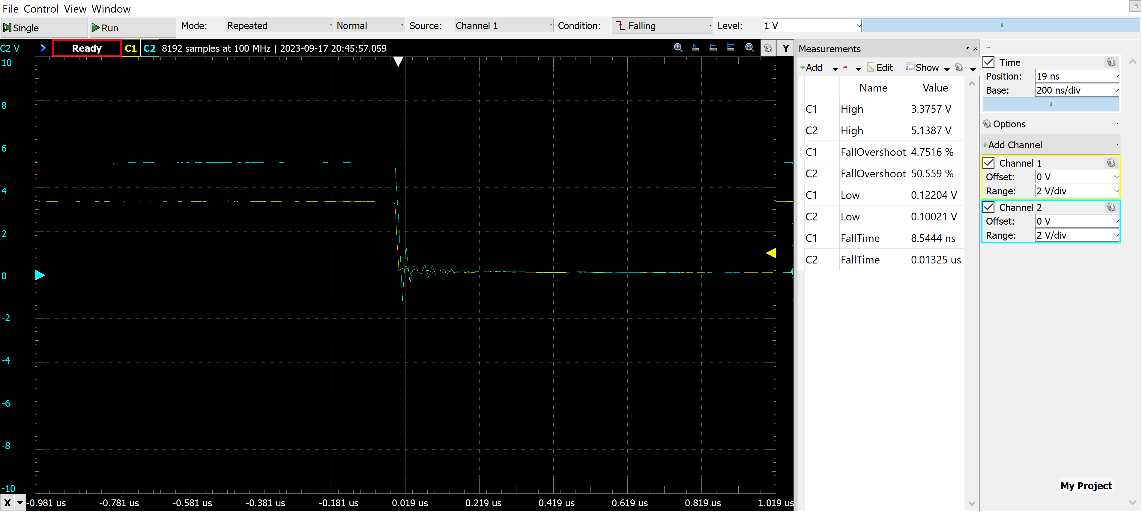

RPI HAT Powerline Communications
- Enable RPI to run powerline comm script at boot.
- Plug RPI HAT into raspberry PI
- Plug RPI HAT in AC home outlet
- Plug JARViE powerline demo board into a home outlet
- …..add more steps
Results
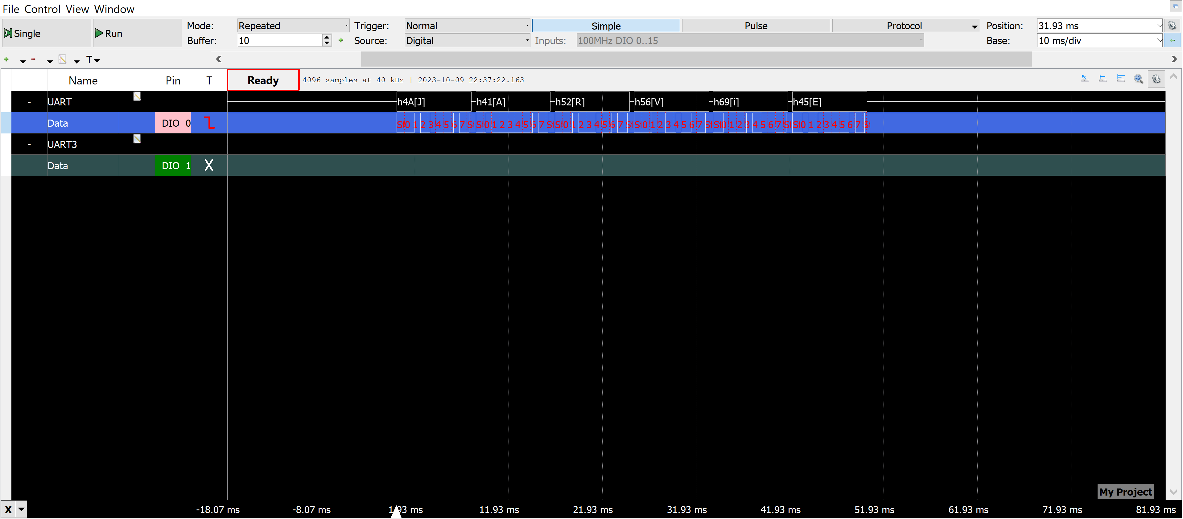

Setup the WLAN
- Connect keyboard and mouse to RPI USB A ports.
- Connect RPI to a display via micro HDMI port.
- Follow instructions here to setup WLAN: https://raspberrytips.com/raspberry-pi-wifi-setup/
- Once the WLAN is setup, connect to a network.
- Verify that the RPI does not lose power or reboot.
- Unpower RPI and apply power via RPI HAT, ensure RPI successfully boots and don’t not get stuck in a boot loop.

Setup Remote Desktop Access (RDP) on RPI
- Open terminal on RPI and type sudo apt-get update to ensure you have the latest apt-get packages. If error is report stating an error or packages were ignored, re-run cmd until all packages install.
- Follow instructions here to setup RDP on the RPI: https://elluminetpress.com/2020/03/connect-to-your-raspberry-pi-remotely/

SSH into RPI
- Enable and login via SSH by following these instructions: https://phoenixnap.com/kb/enable-ssh-raspberry-pi
- Type hostname -I into terminal on RPI, it will print the IP address, this is the IP address to use for the SSH connection in order to SSH into the RPI.
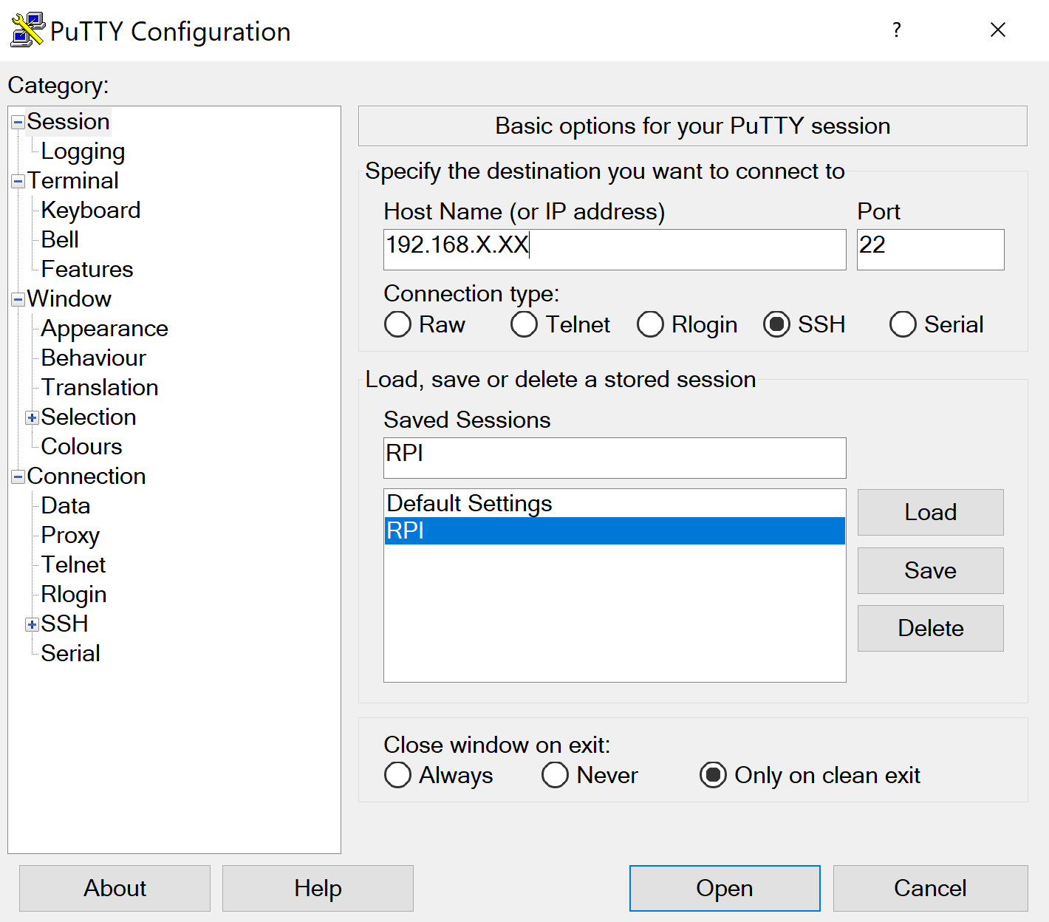

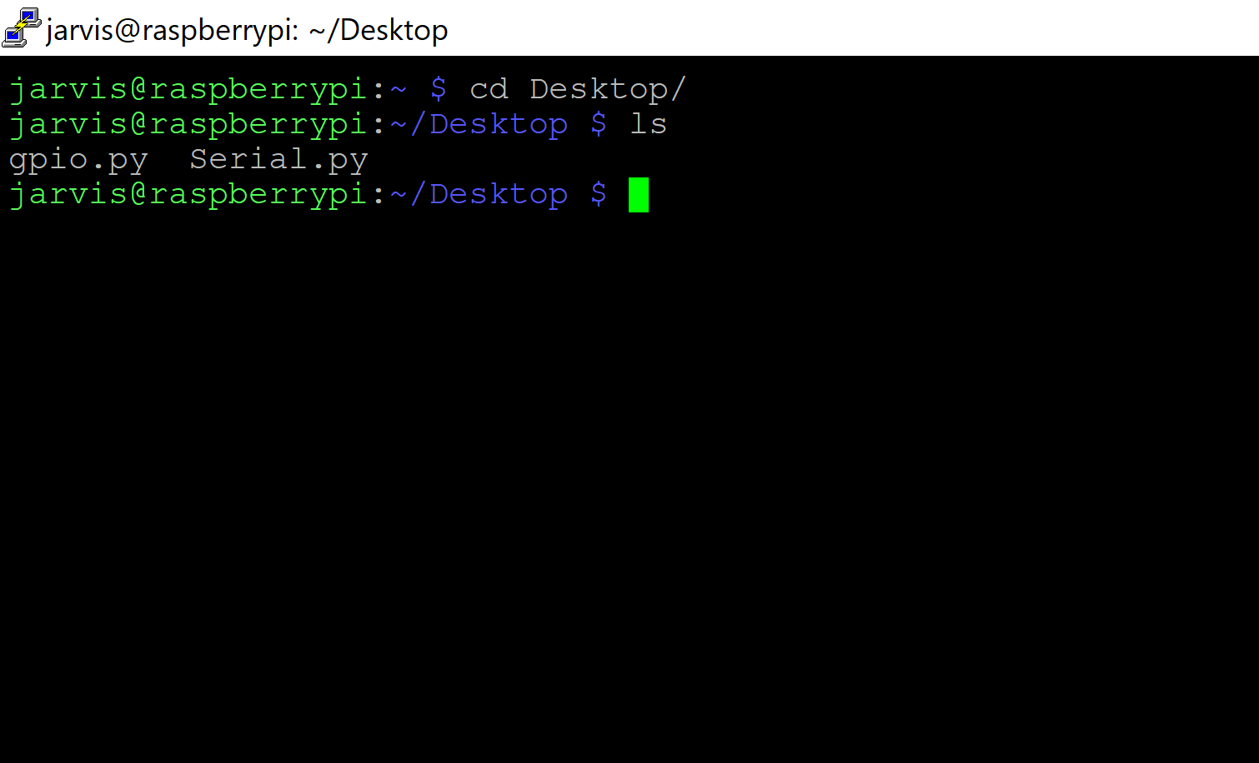
Run Python script at boot (init.d approach is what I used)
- https://www.dexterindustries.com/howto/run-a-program-on-your-raspberry-pi-at-startup/

